CSA0404 OPERATING SYSTEM
LAB PROGRAM
NAME: KAMESH D
REG NO:192565003
PROGRAMS:

QUESTION 1
Create a new process by invoking the appropriate system call. Get the process
identifier of the currently running process and its respective parent using
system calls and display the same using a C program.

CODING :

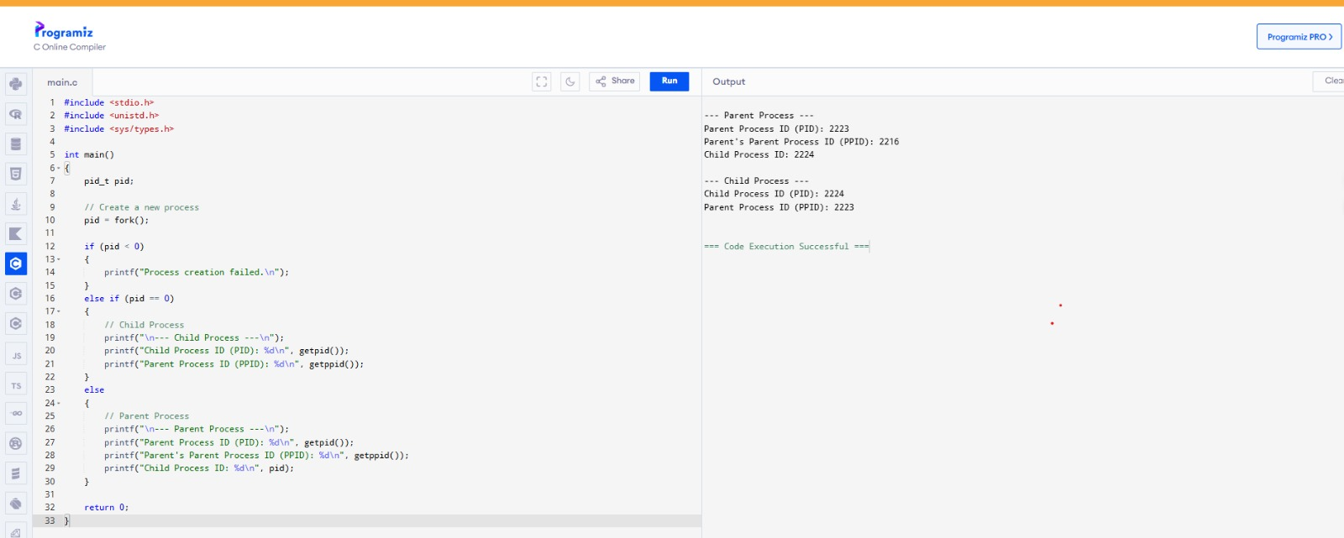

QUESTION 2:

Identify the system calls to copy the content of one file to another and
illustrate the same using a C program

CODING:

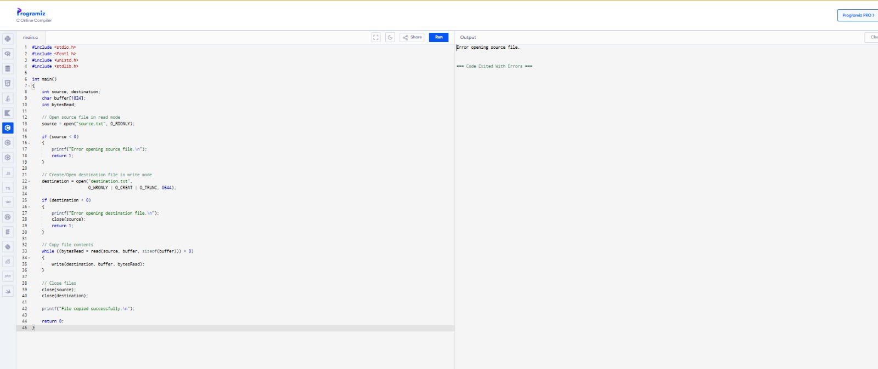

QUESTION 3:

Design a CPU scheduling program with C using First Come First Served.

CODING :

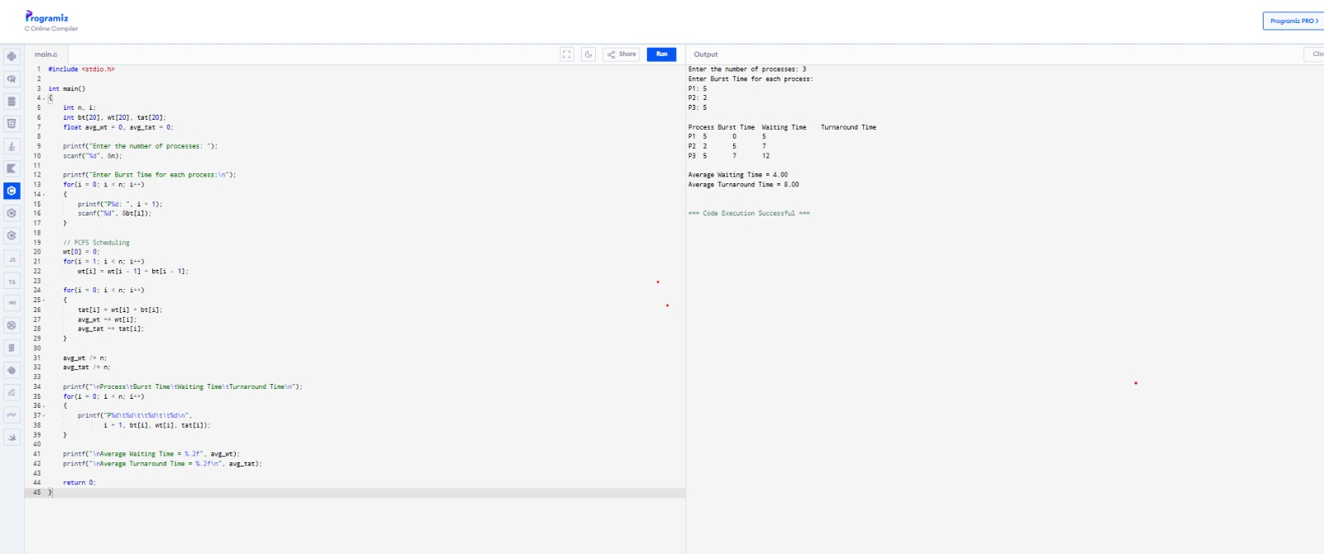

QUESTION 4:

Construct a scheduling program with C that s

CODING:

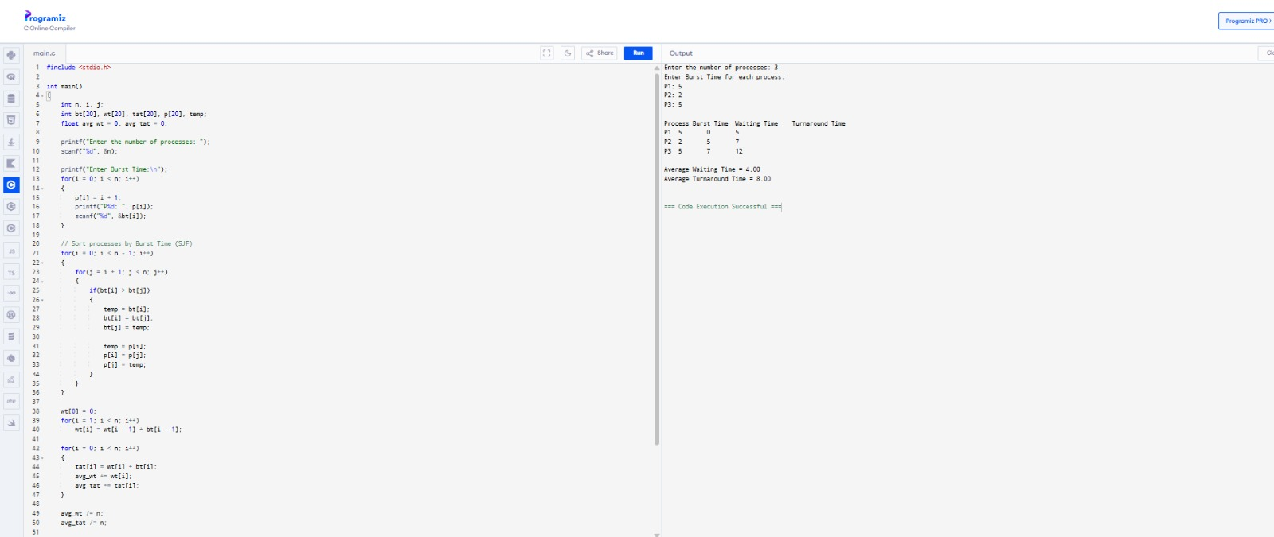

QUESTION 5:

Construct a scheduling program with C that selects the waiting processwith the
highest priority to execute next

CODING:

